Group Agreement and Plan

Group Members
Name | Contact information | Signature
Le Xuan Ny | Student ID (Australia): 105680151  Student Email: 105680151@student.swin.edu.au | 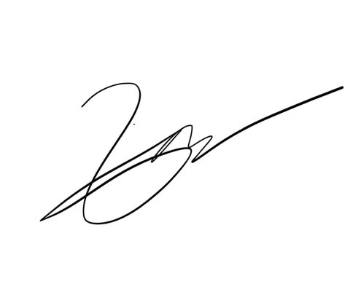
Pahan Pathirathna | Student ID (Australia): 104657523  Student Email: 104657523@student.swin.edu.au | 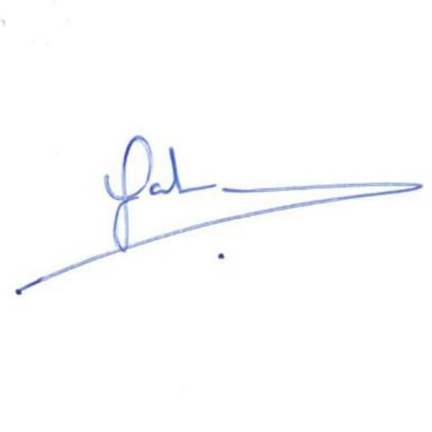
Nguyen Quang Khai | Student ID (Australia): 105560512  Student Email: 105560512@student.swin.edu.au | 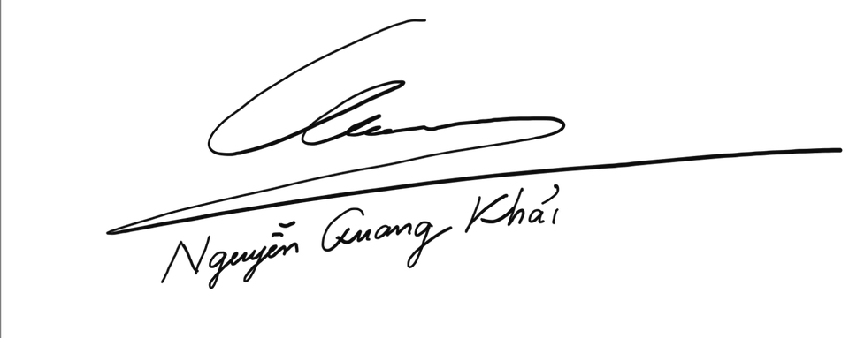
Pham Dinh Duc Anh | Student ID (Australia): 105202964  Student Email: 105202964@student.swin.edu.au | 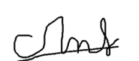
Pham Nguyen Minh Hoang | Student ID (Australia): 105543500  Student Email: 105543500@student.swin.edu.au | 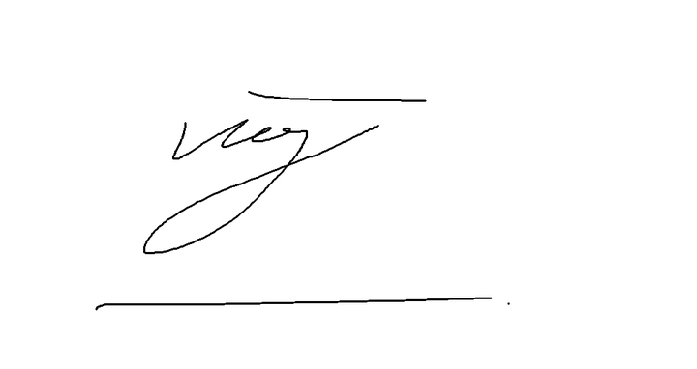
Truong Ngoc Gia Hieu | Student ID (Australia): 105565520  Student Email: 105565520@student.swin.edu.au | 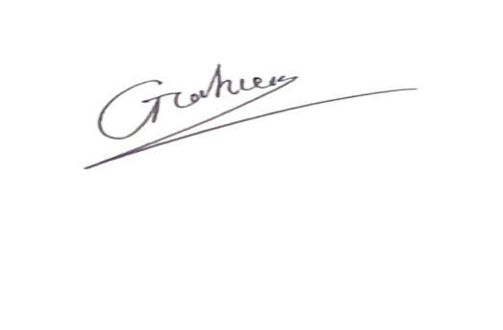

Group name (optional)
What will you call yourselves?

Group style and roles
Who does what and how will you work together? Who will be responsible for submitted deliverables? Who will ask questions on behalf of their group?

Timeline
When do you need to make decisions by? When do tasks need to be done by to make sure you submit on time? (Aim to submit BEFORE the deadline to allow for unforeseen circumstances).

Communication Plan
Decide and document how your group will communicate with each other and collaborate on a regular basis during the project. This could include meeting via Zoom, communicating via a Facebook group, Canvas, using cloud services for shared documents etc. How often and how will you communicate? What are your expectations on others responding to your communications?

On-track behaviours
What behaviours will result in great group outcomes?

Off-track behaviours
What behaviours would result in group outcomes that aren’t great?

Resolving tensions
How will we resolve tensions/off track behaviour as a group?

Team Expectations:
1.

2.

3.

4.

5.

6.

7.

